“ Project Report”

**DIGITAL LOGIC DESIGN**

AROOJ RAHEEL 22I-0601

MALAIKA SALEEM 22I-0509

**Topic:**

Chip tester (OR, NAND, AND, NOR)

**Equipments:**

* 7 OR ICs.
* 6 AND ICs.
* 3 NAND ICs.
* 3 NOR ICs.
* 5 NOT ICs.
* Bread board
* LEDs (Green and Red)

**Proteus diagrams:**

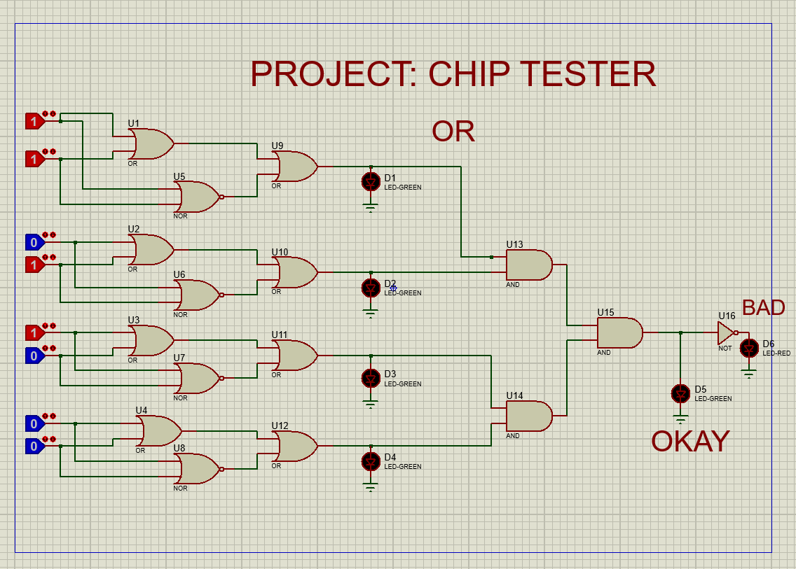

**Circuit Diagram:**

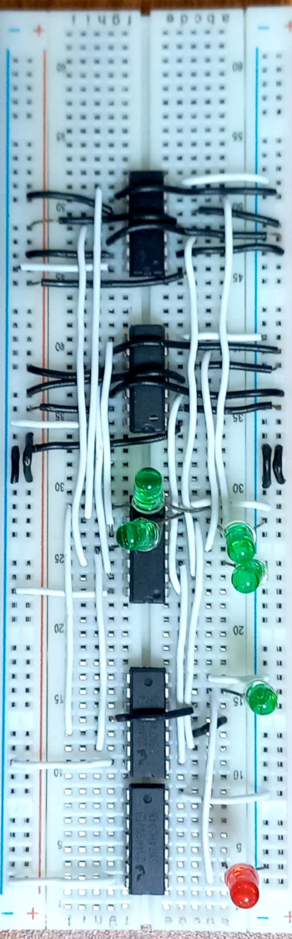

**EXPLANATION:**

Chip tester uses invert ICs to check if the current IC works. In case of OR IC NOR IC is used to verify if its working and in case of AND IC NAND IC is used. In OR IC tester all 4 OR gates in a 7432 IC are connected to input. The same inputs are given to a NOR IC and we take OR between output of both these ICs. The logic behind this is that it if the OR gate is working fine then whatever answer it will give NOR gate will give its inverse so the OR of both will always be 1. But if OR gate is not working NOR will have inverse value so OR may not be equal to 1.By collectively taking AND of all the further outputs we will finally be able to tell if OR IC is working (demonstrated if green LED is turned on) or not (demonstrated if red LED is turned on).

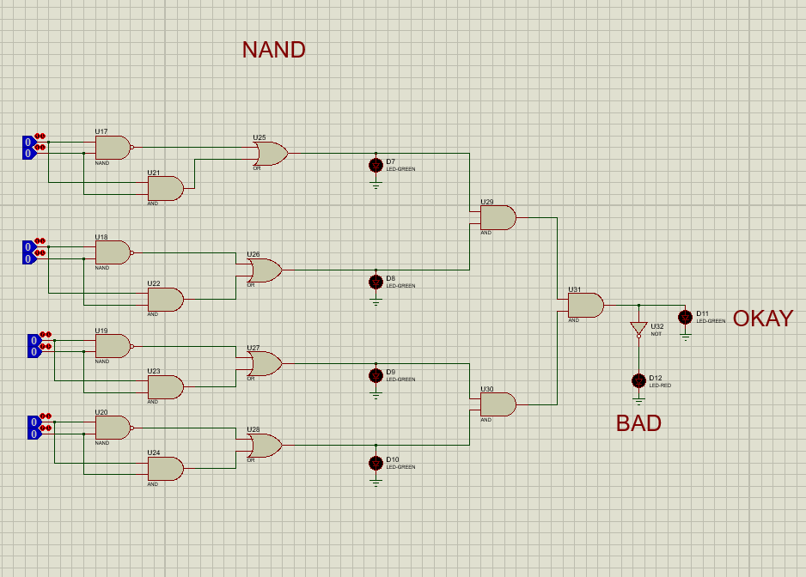

**Circuit diagram:**

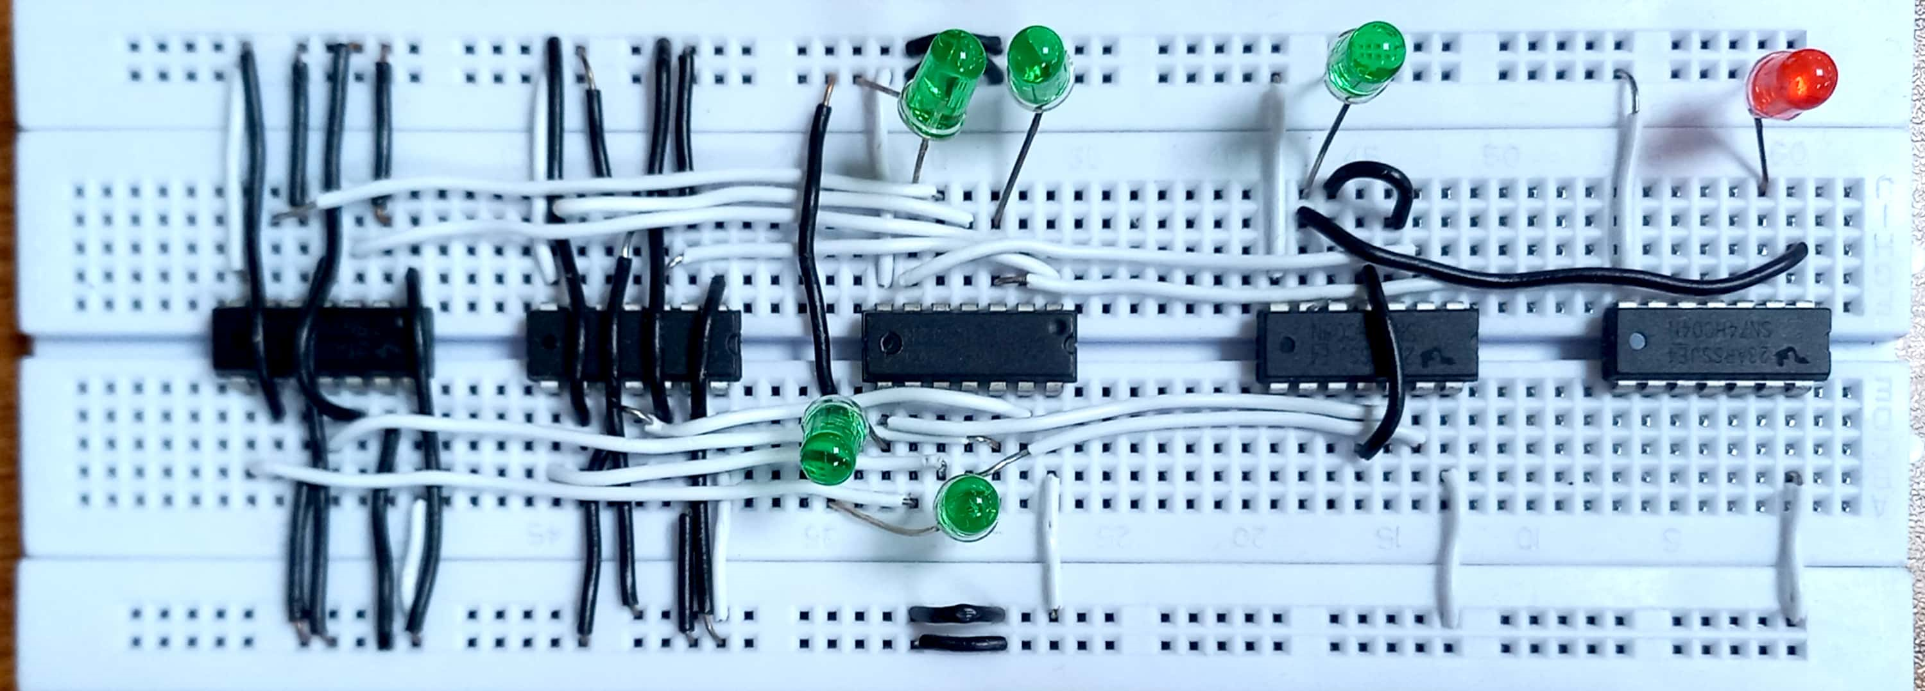

**EXPLANATION:**

Chip tester uses invert ICs to check if the current IC works. In case of NOR IC OR IC is used to verify if its working and in case of NAND IC AND IC is used. In NAND IC tester all 4 NAND gates in a 7400 IC are connected to input. The same inputs are given to an AND IC and we take OR between the output of both these ICs. The logic behind this is that it if the NAND gate is working fine then whatever answer it will give AND gate will give its inverse so the OR of both will always be 1. But if NAND gate is not working AND will have inverse value so OR may not be equal to 1. By collectively taking AND of all the further outputs we will finally be able to tell if NAND IC is working (demonstrated if green LED is turned on) or not (demonstrated if red LED is turned on).

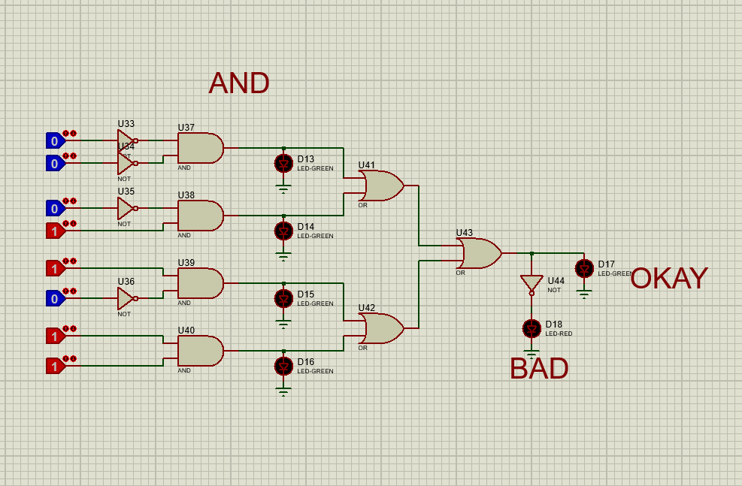

**Circuit diagram:**

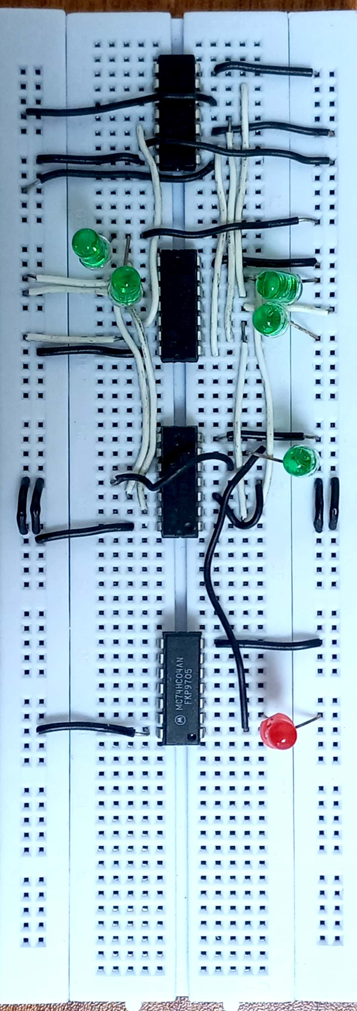

**EXPLANATION:**

Chip tester for AND is simply implementation of SOP expression of AND gate which is:

AB+A’B+AB’+A’B’

The implementation of this expression will always yield 1 if its working correctly and the green light will turn on. However, if the gate is not working correctly then it yield 0 so the red LED will turn on.

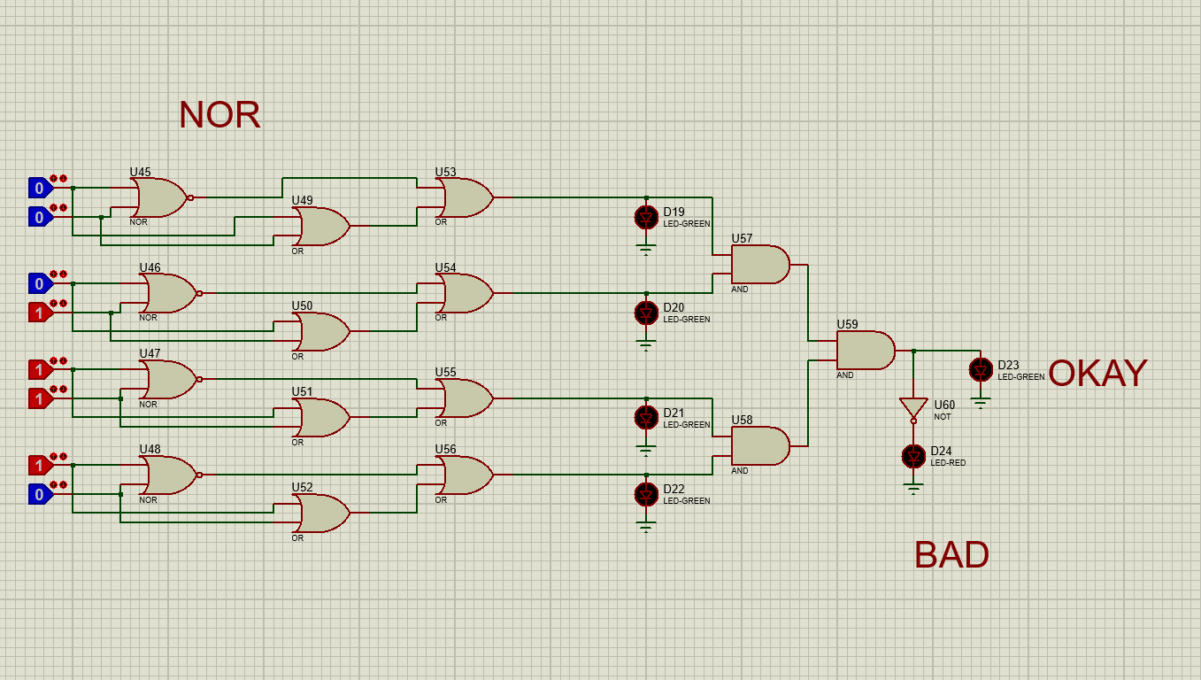

**Circuit Diagram:**

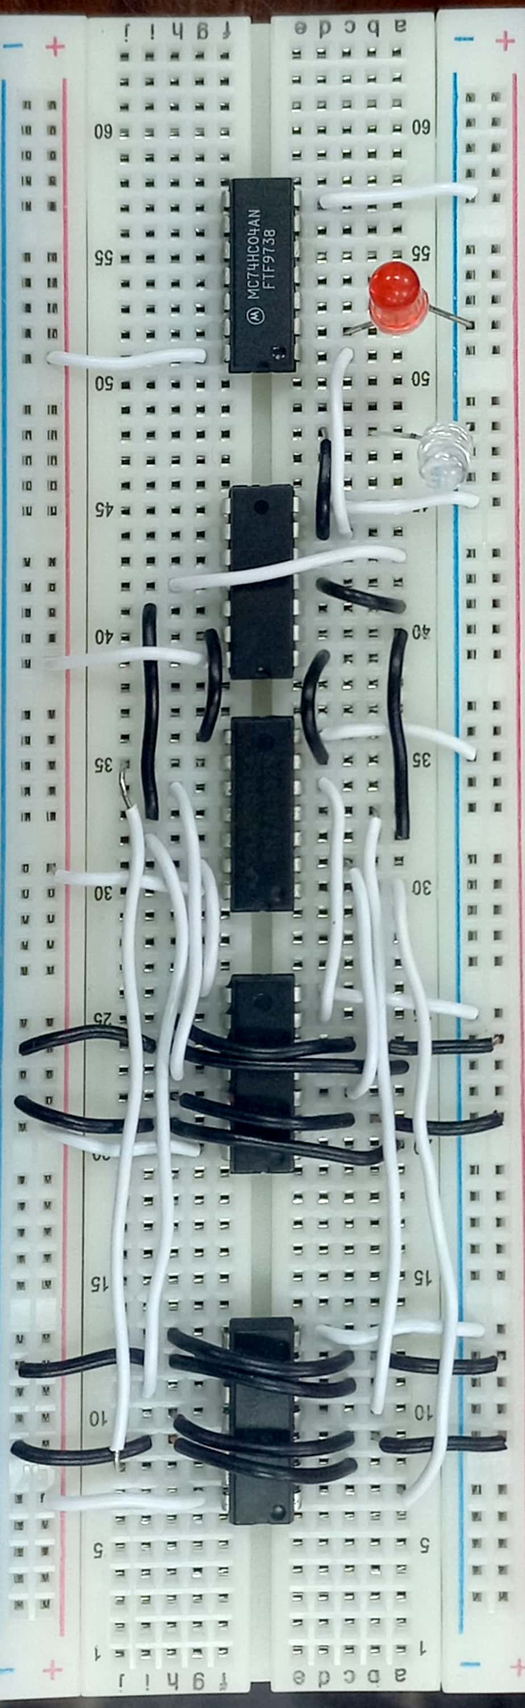

**EXPLANATION:**

Chip tester uses invert ICs to check if the current IC works. In case of NOR IC OR IC is used to verify if its working and in case of NAND IC AND IC is used. In NOR IC tester all 4 NOR gates in a 7402 IC are connected to input. The same inputs are given to an OR IC and we take OR between the output of both these ICs. The logic behind this is that it if the NOR gate is working fine then whatever answer it will give OR gate will give its inverse so the OR of both will always be 1. But if NOR gate is not working OR will have inverse value so OR may not be equal to 1. By collectively taking AND of all the further outputs we will finally be able to tell if NOR IC is working (demonstrated if green LED is turned on) or not (demonstrated if red LED is turned on).

______________________________